https://prezi.com/6bau29vjbqbo/jasper-jones-english-assignment/

Go to the above site. On it are some interviews with silvey worth listening to. Use control click to take you to this and the website below.

http://www.livebinders.com/play/play/427210

This site will give you access to some excellent contextual resources regarding the novel. Key words are Vietnam War, Australia in the 60s and Communism. Find out what you can about these topics.

‘Jasper Jones: A Novel’ by Craig Silvey
By Michael Williams
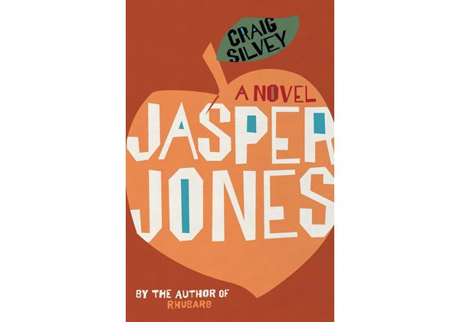
'Jasper Jones: A Novel' by Craig Silvey, Allen and Unwin; RRP $29.99
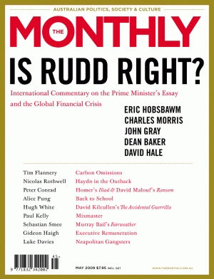May 2009Short read
Topics
Society
Racism
You are reading 1 / 3 free articles this month Already a subscriber?
Log in
Register for 5 articles free a month

Share EmailFacebookTweetGoogle+LinkedIn

Advertisement

From the front page
Slippery migrantsWhat eels do when we're not watchingNames have been changedManaging child sex offenders in the communityRivers ran redIndonesia’s mass killings have been overlooked for 50 yearsBlack listsDoing the right thing in Jay Roach’s ‘Trumbo’ and László Nemes’ ‘Son of Saul’Transition vampWe all know Australia is changing, but no-one can tell us into whatHoly flarkThe Watson family take on ‘Family Feud’#PrisonLifeInternet access in jailsLessons from Louise: the story of Paul Sheehan and the Sydney Morning HeraldPaul Sheehan’s story about the alleged gang rape of “Louise” led, eventually, to him being suspended by Fairfax. But how has a writer so reckless survived for so long at a reputable media company? A special report for the Monthly and Guardian AustraliaThe art of manipulationTrue crime and entertainment in Netflix’s ‘Making a Murderer’
Publisher hyperbole can be off-putting - rarely more so than when it takes the overblown-comparison route. Wariness seems in order when Craig Silvey's publisher suggests that Jasper Jones, Silvey's second novel, is an Australian To Kill a Mockingbird.
To 13-year-old Charlie Bucktin, the mining town of Corrigan is populated by barnacles: "hard shells that ... clench themselves shut and choose not to know" about the outside world. It is 1965, and the insularity of rural Western Australia is an oddly neat setting for a story that aligns itself with an American literary tradition. Charlie is lured by the promise of adventure when the town troublemaker, Jasper Jones, comes to his window one night and asks for help. At the other end of a trek through the sleeping town lies a secret that is adult and painful.
Silvey, whose 2004 novel, Rhubarb, deserved the plaudits it received, understands the difficulty of balancing adult storytelling and adolescent protagonists. Jasper Jones is a well-paced, eminently readable bildungsroman, complete with social commentary, a dab of racism and a distant but morally righteous parent. Silvey knows and proudly identifies his literary antecedents, frequently citing Harper Lee, as well as Twain and Faulkner. The prejudice against Jasper - "half-caste" and outcast - the role of class, and the relationship between the distant Vietnam War and the town's Vietnamese family are all sketched with confidence and grace.
The prose is at times a little forced, the plotting and characterisation occasionally clichéd; but none of that matters. If we see a more entertaining, more heartfelt piece of Australian literature in the next 12 months it will be a rare year indeed. Amid the glimpses of small-town bigotry and adult compromise, Jasper Jones offers tender moments of adolescent romance and irresistible vignettes of friendship and quiet triumph. The exultation contained in the description of a cricket game featuring Charlie's irrepressible best friend ("Jeffrey Lu on debut") is enough alone to earn this book sentimental-classic status.
Unlike Atticus Finch, who embodied Justice, Charlie Bucktin's father embodies the virtues of Literature: Wes Bucktin understands the enduring power - good and bad - of stories. So does his creator. With this singular novel Silvey confirms his place as a young writer to watch. In all important respects Jasper Jones is an Australian To Kill a Mockingbird.
https://www.themonthly.com.au/Jasper-Jones-Craig-Silvey

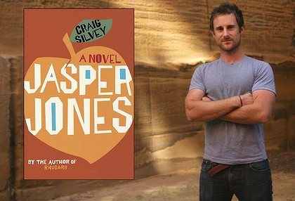
Australian author Craig Silvey. Photo: Marco Del Grande
Reader rating:
Rating: 4 out of 5 stars (99 votes)
Name
Jasper Jones
Author
Craig Silvey
Publisher
Allen & Unwin
Year
2009
Pages
368
RRP
32.95
Craig Silvey showed great promise in 2004 with the publication of his debut novel, Rhubarb. At 22, he had a flair for linguistic experimentation: with tone, rhythms and dynamics. Rhubarb was replete with strange syntax, puns and invented words. Overall, the consensus was that Silvey had talent and, with maturity, he would produce better work.
In some ways his new book lives up to these expectations. Far tamer in style, Jasper Jones has a similar comedic spirit and precociousness. This time, however, Silvey has written for young adults as well as adult readers. Perhaps the younger age of prospective readers weakened more critical reflection: Jasper Jones, like Rhubarb, is marred by tedious repetition and occasional childish wit.
It is the summer of 1965 and Charlie Bucktin is a 13-year-old boy in the mining town of Corrigan. Charlie is engrossed in the novels of William Faulkner, Harper Lee, Flannery O'Connor and Mark Twain. On the sweaty night that he begins reading Pudd'nhead Wilson, Jasper Jones, an older indigenous boy, appears at his window. "Jasper Jones," Charlie explains, "has a terrible reputation in Corrigan. He's a Thief, a Liar, a Thug, a Truant."
Jasper needs Charlie's help. He leads Charlie out of town to his secret glade deep in the bush. Here Laura Wishart hangs dead from a tree. Charlie, terrified, insists on reporting her death but Jasper is convinced that it is murder and that he is being framed for it: "This town, they think I'm a bloody animal ... They don't need any more than what they see right here." So they cut Laura from the tree, weigh down her body with granite and dump it in a dam. Pledging secrecy, Jasper and Charlie also vow to expose Laura's killer.
Advertisement
Despite the queasy opening, Jasper Jones does not take itself too seriously. It is, in essence, a coming-of-age narrative with an intervening murder. Charlie is the typical unlikely hero: geeky, frail and far too introspective. His transition from awkward pre-pubescence to adolescence, learning the hard lessons of small-town social mores, parental restrictions and burgeoning love, is sensitively drawn.
The banter between Charlie and his best friend, Jeffrey Lu, is authentic and often funny. But Silvey lacks restraint for how long can even the most ardent fan read about cricket or engage with the boys' over-zealous philosophising on the masculine complexities ofBatman?
The narrative structure is effectively complicated by race issues a noxious current that runs through Corrigan. The political backdrop (Australia has just increased its troop commitment in Vietnam) also creates tension, particularly for the Lu family, who are Vietnamese immigrants.
There are moments when Silvey loses the thread of Charlie's voice, slipping into a more sophisticated register. How many 13-year-olds, however bookish, admire their fathers for never "stoop[ing] to sycophancy", or describe themselves as a "whirring zoetrope of half-thoughts"? And the excessive use of the insult "queer" and "retard" is uncomfortably conspicuous.
Jasper Jones is not without flaws. But when Silvey remembers to tone down the puerility, it is an engaging historical portrait of an ambitious, intelligent boy labouring often amusingly under the parochialism of an isolated town.
Read more: http://www.theage.com.au/entertainment/books/jasper-jones-20100317-qfcf.html#ixzz43Vi1fhdr
Follow us: @theage on Twitter | theageAustralia on Facebook

Book Reviews for Jasper Jones by Craig Silvey
Author: Craig Silvey

» Submit your own book review for Jasper Jones by Craig Silvey and earn Boomerang Bucks loyalty dollars!
Book Review: Jasper Jones by Craig Silvey - CloggieA 11 Apr 2011
Jasper Jones is Craig Silvey’s second novel. It is set during a hot summer in 1965 in a small West Australian town, Corrigan, and narrated by thirteen-year-old Charlie Bucktin. Charlie is surprised by Jasper Jones’ appearance at his sleepout window: Jasper needs his help. Jasper, mixed race, rebellious and solitary, represents danger and intrigue for Charlie: he is desperate to impress him and so goes along with Jasper. This action unleashes a sequence of events that will change Charlie, Jasper and the people of the town of Corrigan. Silvey’s elegant prose touches on racism, adultry, truth and lies, human weakness, falling in love, trust, small-town boredom, cricket, coming of age, love of literature, hope and despair and long-kept secrets. Silvey’s characters are compelling, his dialogue is credible and his plot takes a few unexpected turns. The subject matter could have been heavy going, but Silvey provides us with exceptional comic relief in the delightful Jeffrey Lu, Charlie’s best friend. Jeffrey’s conversations with Charlie provide many laugh-out-loud moments. Charlie’s relationship with his father, Wes, and later with his prospective girlfriend, Eliza, provide a heartening contrast to some other aspects of the story. Jasper Jones is an outstanding and decidedly enjoyable novel: let us hope for more like this from Craig Silvey.
Book Review: Jasper Jones by Craig Silvey - AmandaMM 19 Nov 2009
This is my favourite book for this year! An Australian "coming of age" novel with nods to both Harper Lee and Mark Twain, I think Silvey's "Jasper Jones" is set to become our version of "To Kill a Mockingbird" and should be on all high school reading lists. His well developed characters always ring true and the plot moves very well indeed as we follow Charlie, Jasper and Jeffrey through the summer that will change all their lives. Craig Silvey evokes the torpor of a long, hot summer in small-town Western Australia and accurately depicts the petty meanness, ignorance and prejudices inherent in some levels of every small community. As they move out of childhood and begin to work out the kind of adults they will eventually become, Charlie and Jeffrey simply glow with life as they face, and come to terms with, their first challenges. I truly loved this book, not least because of the insight it has given me into the machinations of my own teenaged sons mind and would eagerly recommend it.

http://www.boomerangbooks.com.au/Jasper-Jones/Craig-Silvey/book_reviews_9781741757743.htm

Craig Silvey, Jasper Jones (Review)
September 20, 2009
tags: Australian writers, Coming of age novels, Craig Silvey, Jasper Jones
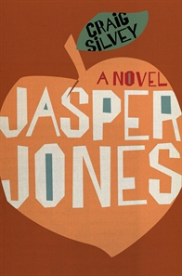
Jasper Jones cover (Courtesy Allen & Unwin)
What is is about coming-of-age novels? Why do we like to read them long after we’ve (hopefully) come of age ourselves? Is it because we like to compare our own experience with that of others? Whatever the reason, it is clear that we do like to read them because they sure keep being written and published. In my few months of blogging I have already written about two, and have now read another, Craig Silvey’s Jasper Jones.
Like many, though not all, such novels, Jasper Jones has a first person narrator. It is set in a small country town in Western Australia in the late 1960s, and the protagonist, Charlie, is the nearly 14-year-old son of a high school literature teacher. He is a reader and therefore, almost by definition in the world of teenage boys, not “cool”. The book opens with the town’s bad-boy, Jasper Jones, knocking on his window in the middle of the night and, to Charlie’s surprise and delight, asking him for his help. The plot revolves around the shocking help that Jasper wants, how Charlie responds and the impact on him, his friends and family.
It is a pretty dark and gritty story, and Silvey, mostly, controls it well, though there are times when he pushes the melodrama button a little too heavily. Silvey teases us at the beginning with the notion that the book will be a re-setting of Harper Lee’s To kill a mockingbird. There’s a death, an indigenous person likely to be blamed for it, a much maligned apparently “mad” person, an apparently thoughtful and wise father AND Charlie’s own regular reference to the book and to how Atticus Finch might think in particular situations. However, fortunately I think, Silvey is a little more sophisticated a writer than that and Harper Lee’s book functions more as a frame for the story and the ideas being explored than as a direct model for the plot.
One of the things I like in the novel is the friendship between Charlie and his Vietnamese refugee school-mate, Jeffrey Lu. I’m not a teenage boy but I have known some in my time! The dialogue between the two boys rings pretty true – their puns, their ribbing of each other, their jokey arguments. True too is their uneven burgeoning interest in the opposite sex – Charlie is attracted to classmate Eliza Wishart and to enjoying some “sassytime” with her, while Jeffrey’s focus is on making the town cricket team.
The novel is neatly plotted – and while some of it is predictable it is not all so. The fact that Charlie fears insects seems to be resolved when we discover that his love-interest Eliza has a similar fear – but it reappears again, cleverly, in the denouement. The story is well-paced, and it deals with a range of side issues, such as racism (against the Vietnamese refugee family, and the “half-caste” Jasper Jones), on top of the usual coming-of-age ones, such as loss of innocence (in several meanings of the word). Many of the characters could be seen as stereotyped – the “bastard” cricket coach who aligns himself with the “boorish” bully boys, and the cold-hearted status-seeking shire president, to name two – but most of them work despite this. Charlie’s mother though stretches the imagination a little too much: she has married down, she has been forced to live in a country town too small for her, and she has lost a child. This does seem a bit of overkill and the panning out of her part of the story feels a bit like one too many layers in the book.
One of the concepts that Charlie explores is that of “timing and chance”. He learns that despite your best laid plans, time and chance sometimes take over and there’s not much you can do about it. Another issue that runs through the book is that of reading, words and language. Early on Jasper Jones tells Charlie he trusts him because:
:
But I hope you might see things from my end. That’s what you do, right? When you’re reading. You’re seeing what it’s like for other people.
With this coming near the beginning of the book, it’s not surprising that Charlie’s ability to empathise, to see things from other points of view, is pushed to the limits as the story progresses. Charlie, whose ambition is to be a writer, also learns about the limits of words, about when they are useful and when they are not, and about finding the right ones to use when they are.
There are many thematic and stylistic things that can be talked about in this book, making it a good one for discussion but, in the end, it is a fairly traditional coming-of-age story in its style, tone and structure. That said, if you like such stories, as I do, there’s a good chance you’ll find this a compelling and entertaining even if not a particularly challenging read. And is there anything wrong with that?
Craig Silvey
Jasper Jones
Sydney: Allen & Unwin, 2009
368pp.
ISBN: 9781741757743
http://whisperinggums.com/2009/09/20/craig-silvey-jasper-jones/

Smalltown boys: discrimination and isolation in 1960s Australia
- Download audio
Friday 1 May 2009 10:24AM (view full episode)
What would you do if the town's troublemaker knocked on your window late at night and asked for help?
That's the dilemma for 13-year-old Charlie, the narrator of Jasper Jones, the new novel by Australian writer Craig Silvey.
The book is set in a fictitious Western Australian mining town called Corrigan during the summer of 1965.
Jasper Jones is the misfit who knocks on Charlie's window needing help. He's trying to avoid taking the heat for a crime he says he didn't commit.
His plea appeals to Charlie's sense of fairness and justice.
The bookish Charlie and the Aboriginal Jasper both know what it's like to be marginalised in a small town.

